**DBS311A Lab 6**

1.

create or replace PROCEDURE Even_Odd(v_value1 NUMBER)

IS

division NUMBER := 0;

BEGIN

division := MOD(v_value1, 2);

IF division = 0

THEN DBMS_OUTPUT.PUT_LINE ('The number '|| v_value1 ||' is even');

ELSE

DBMS_OUTPUT.PUT_LINE ('The number '|| v_value1 ||' is odd');

END IF;

END Even_Odd;

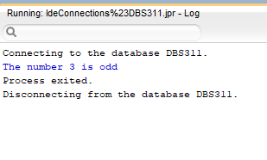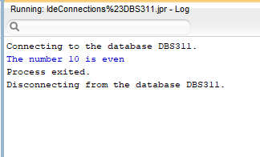

2.

create or replace PROCEDURE CALCULATE_SALARY(emp_id NUMBER)

IS

firstName employee.first_name%TYPE;

lastName employee.last_name%TYPE;

u_salary employee.salary%TYPE;

hire_year NUMBER;

current_year NUMBER;

BEGIN

SELECT first_name, last_name, salary, EXTRACT(YEAR FROM (hire_date)) INTO firstName, lastName,u_salary, hire_year FROM employee WHERE employee_id=emp_id;

SELECT EXTRACT(YEAR FROM (SYSDATE)) INTO current_year FROM DUAL;

IF((current_year-hire_year)>2)

THEN

FOR i IN 2..(current_year - hire_year) LOOP

u_salary:=u_salary*(1+5/100);

END LOOP;

END IF;

DBMS_OUTPUT.PUT_LINE ('First Name: '||firstName);

DBMS_OUTPUT.PUT_LINE ('Last Name: '||lastName);

DBMS_OUTPUT.PUT_LINE ('Annual Salary: $'||u_salary);

EXCEPTION

WHEN NO_DATA_FOUND THEN

DBMS_OUTPUT.PUT_LINE ('Invalid Id');

WHEN OTHERS THEN

DBMS_OUTPUT.PUT_LINE('SOME ERROR HAPPENED');

END CALCULATE_SALARY;

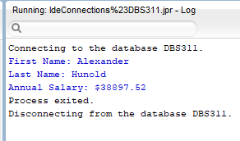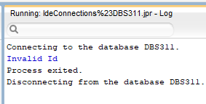

3.

create or replace PROCEDURE FIND_PROD_PRICE(prod_id IN NUMBER, p_description OUT products.description%TYPE, status OUT VARCHAR) IS

p_price products.list_price%TYPE;

BEGIN

SELECT description, list_price INTO p_description, p_price FROM products WHERE product_id=prod_id;

IF(p_price < 200)

THEN

status:='Cheap';

ELSE

IF(p_price >= 200 AND p_price <=500)

THEN

status:='Not Expensive';

ELSE

IF(p_price > 500)

THEN

status:='Expensive';

END IF;

END IF;

END IF;

EXCEPTION

WHEN NO_DATA_FOUND THEN

DBMS_OUTPUT.PUT_LINE ('Invalid Id');

p_description:='N/A';

status:='N/A';

WHEN OTHERS THEN

DBMS_OUTPUT.PUT_LINE('SOME ERROR HAPPENED');

END FIND_PROD_PRICE;

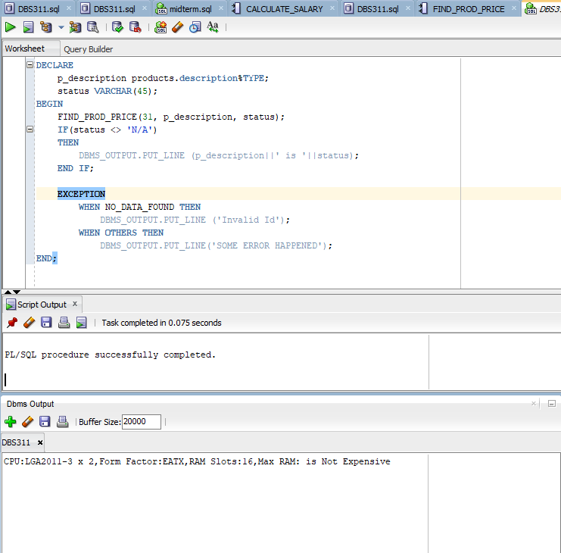

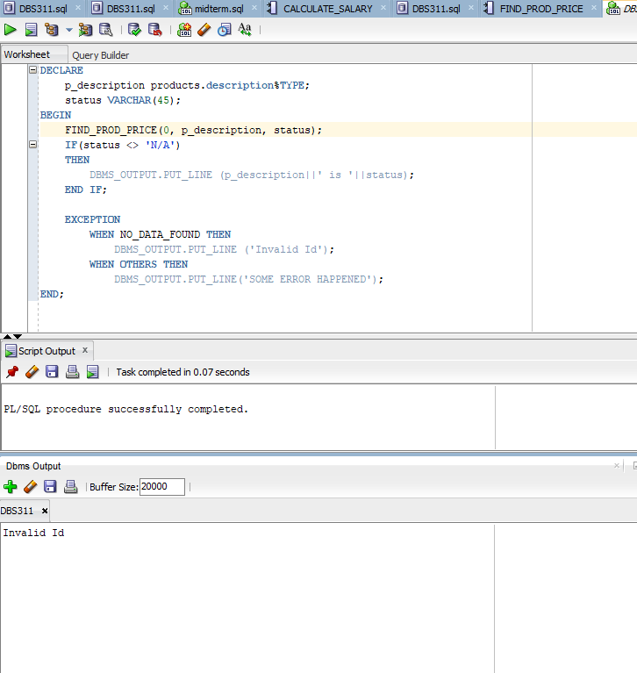

4.

create or replace PROCEDURE WAREHOUSES_REPORT IS

wh_id warehouses.warehouse_id%TYPE;

wh_name warehouses.warehouse_name%TYPE;

wh_city locations.city%TYPE;

wh_state locations.state%TYPE;

BEGIN

FOR i IN 1..9 LOOP

SELECT warehouse_id, warehouse_name, city, state INTO wh_id,wh_name,wh_city,wh_state FROM warehouses JOIN locations USING(location_id) WHERE warehouse_id=i;

DBMS_OUTPUT.PUT_LINE('--------------');

DBMS_OUTPUT.PUT_LINE('Warehouse ID: '||wh_id);

DBMS_OUTPUT.PUT_LINE('Warehouse name: '||wh_name);

DBMS_OUTPUT.PUT_LINE('City: '||wh_city);

IF(wh_state IS NULL)

THEN

wh_state:='no state';

END IF;

DBMS_OUTPUT.PUT_LINE('State: '||wh_state);

END LOOP;

EXCEPTION

WHEN OTHERS THEN

DBMS_OUTPUT.PUT_LINE('SOME ERROR HAPPENED');

END WAREHOUSES_REPORT;

